K. White Jr. High Library
Is having a Book Giveaway
Students may enter the giveaway each time they check out books.
Beginning Nov. 6th through Dec. 18th
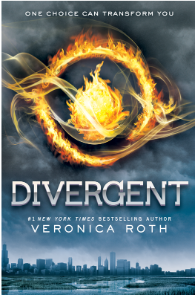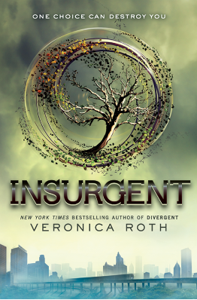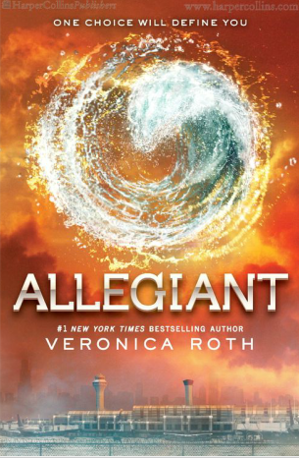
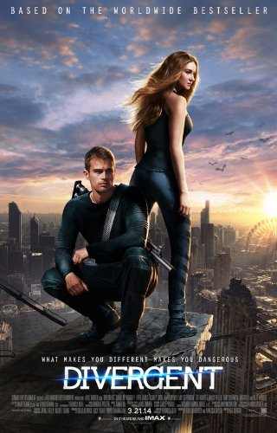
Books and Poster winner will be announced on Dec. 19th during Morning Announcements
One student will win the Divergent Trilogy and the Divergent Movie Poster.

